**Hematology Image Segmentation Report**

**1. Introduction**

Hematology image segmentation plays a crucial role in medical image analysis, particularly in distinguishing White Blood Cells (WBCs) from the background. This report presents a step-by-step approach for segmenting WBCs using intensity-based thresholding and connected component analysis. The results include Dice Score and Accuracy metrics, providing a quantitative measure of the segmentation performance.

**2. Flowchart of the Segmentation Process**

Below is the flowchart representing the segmentation process:

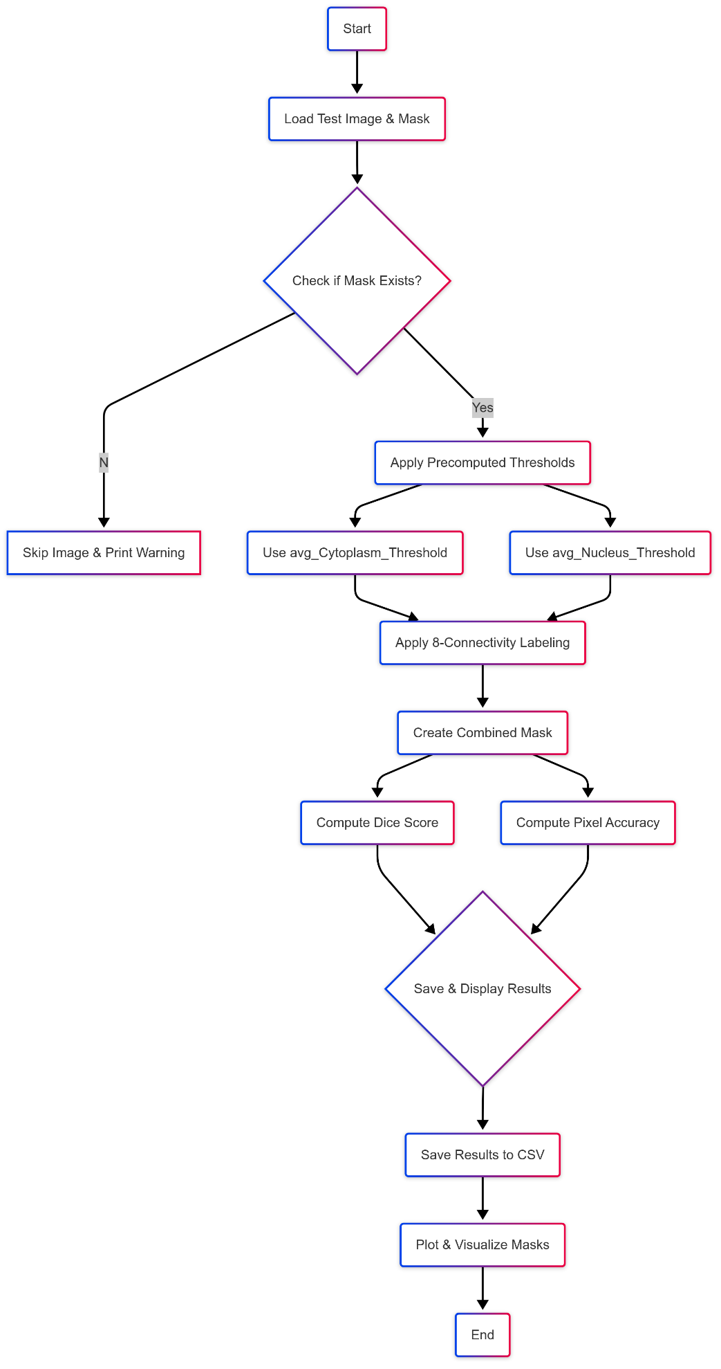

**3. Selection of V Set for WBC Segmentation**

**Step 1: Defining the Initial V Set for WBC Segmentation**

I selected the **V set** carefully to ensure accurate segmentation of White Blood Cells (WBCs) from the background. Using **intensity-based thresholding**, I analyzed the **pixel intensity histogram** to determine an optimal threshold. The initial V set classified pixels above this threshold as WBCs and the rest as background.

**Step 2: Applying Connected Component Analysis (CCA)**

I applied **8-connectivity-based Connected Component Analysis (CCA)** to label connected regions. This ensured that all segmented WBCs were correctly grouped while removing noise. The **8-connectivity** approach helped in identifying WBCs that may have been partially segmented due to intensity variations.

**Step 3: Refining the V Set for Nucleus and Cytoplasm Segmentation**

I applied a **second intensity thresholding step** to separate the nucleus from the cytoplasm. Since the nucleus appears darker than the cytoplasm, I used **average intensity values** from training images to refine the segmentation. This created a **refined V set**, ensuring the nucleus was distinctly separated from the cytoplasm.

**4. Training and Testing Analysis**

**4.1 Single Image Analysis**

The initial segmentation results were assessed on individual images, analyzing thresholds for cytoplasm and nucleus detection. Below is a sample output of **df_train.head()**, showing computed threshold values and performance metrics.

**4.2 Train-Test Performance Evaluation**

The segmentation model was evaluated using the test dataset, computing **Dice Score and Accuracy** for performance comparison. The **df_test.head()** output demonstrates the results on test images.

**4.3 Confusion Matrix & Histogram Analysis**

* **Confusion Matrix:** Visualizes the classification performance of segmented masks.
* **Histogram Analysis:** Helps analyze the distribution of intensity values used for segmentation.

**4.4 Average Dice Score and Accuracy**

The overall performance metrics were computed as follows:



Results:

* **Mean Dice Score:** 0.9301
* **Mean Accuracy:** 0.9439

**5. Conclusion**

This report demonstrates a systematic approach for WBC segmentation using intensity-based thresholding and Connected Component Analysis. The method effectively separates WBCs from the background and further segments the nucleus from the cytoplasm. Performance metrics confirm the reliability of the approach.

Future improvements could involve **deep learning-based segmentation** to enhance accuracy and robustness.